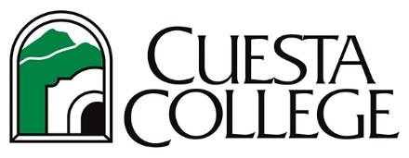

MEASURE L – BID TIMELINE

Milestone Dates for:
Cuesta College SLO Chiller Replacement Project

Advertisement Dates: 10/21/21 & 10/28/21

Bid Walk Date & Time (Non-Mandatory): November 2, 2021
Bid Due Date & Time: November 16, 2021 10:00AM
Bid Opening: November 16, 2021 10:00AM Start of Construction: October 17, 2022
Substantial Completion: January 13, 2023
Final Completion: February 10, 2023
Plans, Specifications, and Addendums available at the Cuesta College online plan room @ https://www.cuestabids.com/jobs/public

